PRACTICAL-9

Assume, JK Enterprises had acquired PDQ Inc. to increase its business presence in the Asia Pacific region with five employees added. A new identity feed (service) into IBM Security Identity Manager will be created to read data (new employee’s data of PDQ Inc.) from a Lightweight Directory Access Protocol (LDAP) server at PDQ Inc.

## **inetOrgPerson service type**

This feed uses a directory resource as the source for the feed. This identity feed loads all inetOrgPerson objects under a specified base. Records that do not have objectclass=inetOrgPerson are ignored.

When you create a service instance for this identity feed, the following information is required:

* URL used to connect to the directory resource
* User ID and password to gain access to the resource
* Naming context, which is the search base in LDAP terminology, and defines where in the directory tree to begin the search
* Name attribute, which must be selected from the values that are provided

Tasks to be done:

Creating an LDAP InetOrgPerson identity feed

* Preparing for the load
* Creating and testing the identity feed

pdq.ldif

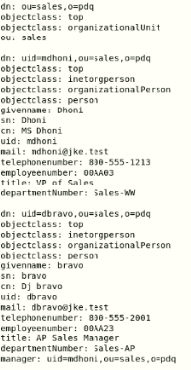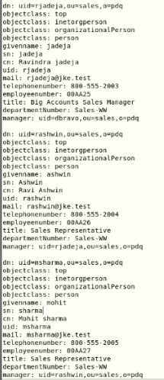

1. Preparing for the load

Import users from the PDQ LDAP Server which for the purposes of this class, is the same LDAP server that is installed on the class computer.The PDQ user entries are stored in the directory under ou=sales,o=PDQ.

* 1. Use LDAP Browser or Web Admin tool to browse those users.Open the LDAP Browser from Desktop.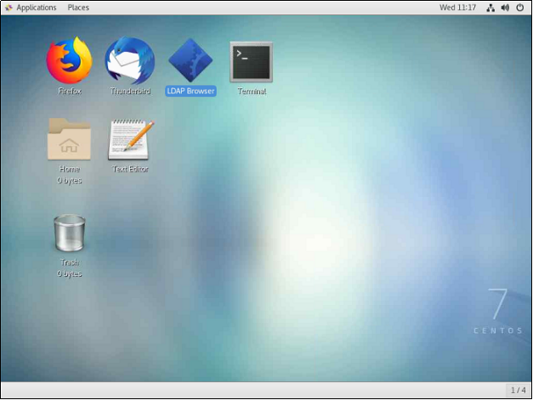
  2. Select PDQ INC from the session list and click on connect.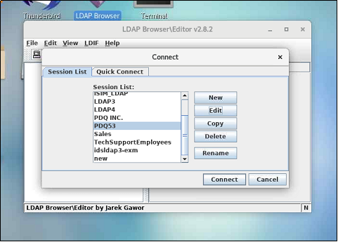
  3. Expand O=PDQ

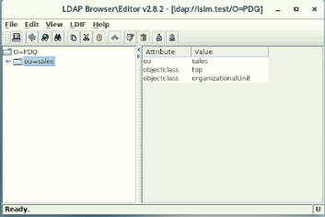

* 1. Expand ou=sales.Confirm there are five users in the PDQ organization to import with this identity feed.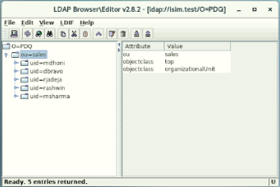

1. Creating and testing the identity feed
   1. Log in to the IBM Security Identity Manager Administrative Console as the system administrator with the user ID itim manager.

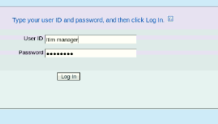

* 1. On the Home tab, navigate to Manage Services.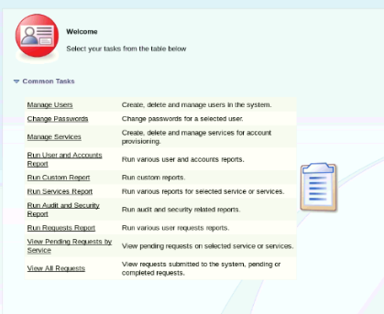
  2. Click Create.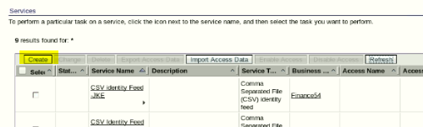
  3. Complete the Create a Service form with the following information:(SALES53)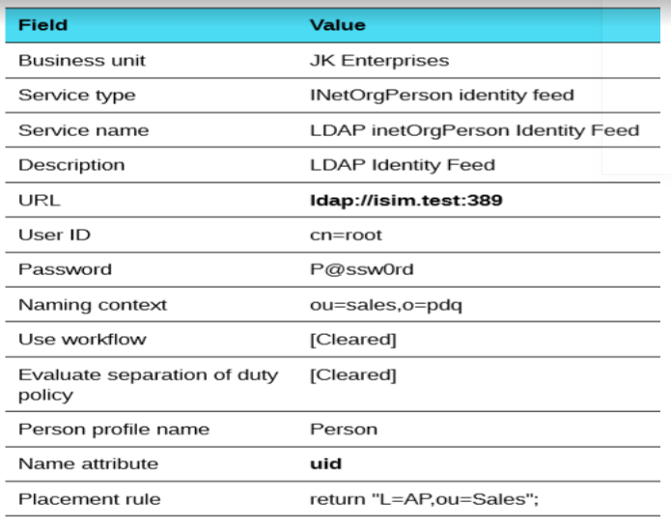

Note:The placement rule uses L=AP,ou=Sales53 to indicate that new users are placed in the AP Location, which is located under the Sales53 Organizational Unit.

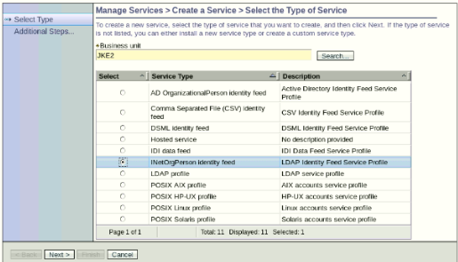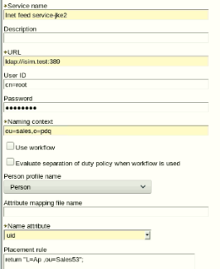

* 1. Click Test Connection.If the connection is successful, click Finish. If it is not, check that you correctly entered the URL, user ID, and Password.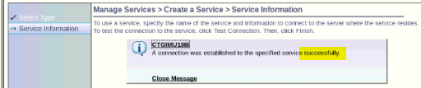
  2. When you see the message that you successfully created the identity feed, click Close.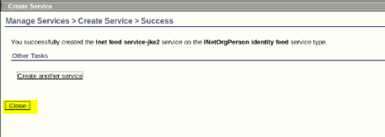
  3. From Manage Services > Select a Service, click Refresh until the new service is shown in the list.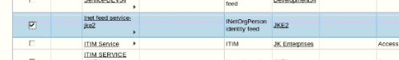
  4. Click the small triangle to the right of the new service name and then click Reconcile Now.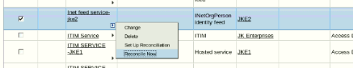
  5. When you see the message that you successfully submitted a reconciliation request, click View my request.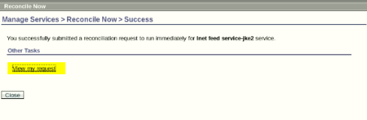
  6. If the initial status of the request shows that it is in the pending state, click Refresh (wait for a minute) until it shows success.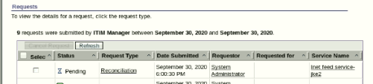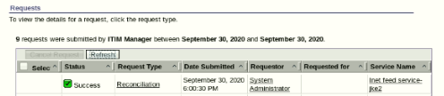
  7. On the Home tab, navigate to Manage Users area. Confirm that five new users are added to the AP location of the Sales53 division.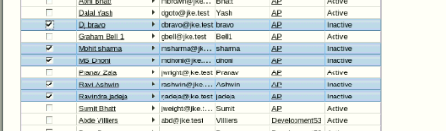

Note:The users are imported but marked as inactive. IBM Security Identity Manager marks the users inactive because they do not have a userPasssword attribute set in the source LDAP.

* 1. To activate each user, select the user and click Restore and then click Submit and then Click Close. Repeat these steps for each inactive user. Close the Reconcile Now tab.

